The Paideia Seminar

ACTIVE THINKING THROUGH DIALOGUE

What Is The Paideia Philosophy?
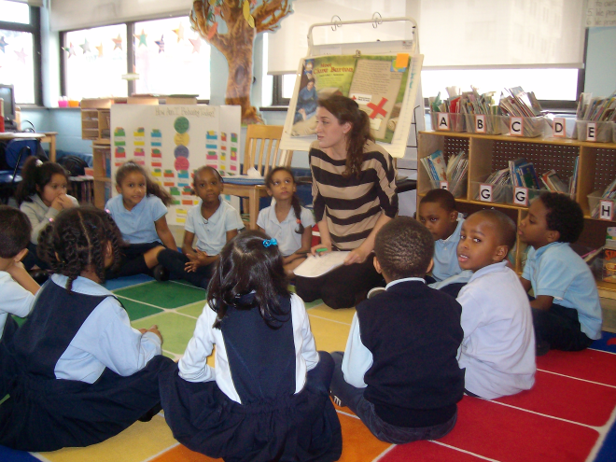
Paideia is the Greek word for the proper upbringing of children. Paideia is a teaching philosophy proposed by Mortimer Adler and based on the belief that all children can learn and that all children are entitled to the best education possible.

What is the responsibility of each seminar participant?
Seminar participants sit in a circle with the facilitator and are expected to listen, speak, think, refer to the text, and address others respectfully.

Principles of the Paideia Program
*Schooling at its best is preparation for becoming generally educated in the course of a whole lifetime, and that schools should be judged on how well they provide such preparation.
*The three types of teaching that should occur in our schools are didactic teaching of subject matter, coaching, and Socratic questioning in seminar discussions.
What is The Paideia Seminar?
The National Paideia Center defines the Seminar as a collaborative, intellectual dialogue facilitated with open-ended questions about a text. The purpose of the seminar is to increase understanding of the textual ideas and values as well as understanding of the self and others.

The Paideia Seminar at HCCS
Students at HCCS have been participating in seminars since the school’s inception. All grades, K – 8, have been participating in seminars, usually as a culminating activity after a unit of study, once a month. This year, as part of our efforts to increase vigor in our classrooms, seminars will be conducted twice a month.
Students at HCCS learn how to set individual goals for themselves as seminar participants. Students are also asked to reflect on their seminar performance, giving them the opportunity to improve themselves in upcoming seminars.
The Paideia Seminar, and its intellectual rigor paves the road for college and career readiness.

