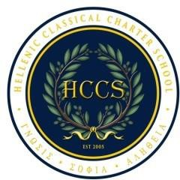

# HELLENIC CLASSICAL CHARTER SCHOOLS (HCCS)

**Park Slope (PS), est. 2005 ~ Staten Island (SI), est. 2019 NOTICE OF SCHOOL BOARD MEETINGS**

Wednesday, May 21, 2025

Open Meeting for HCCS-PS & HCCS-SI - 10:30 a.m.

# Location 1: (in person & ZOOM)

HCCS-PS, 646 5th Avenue, Brooklyn, N.Y. 11215

# Location 2: (in person & ZOOM)

HCCS-SI, 1641 Richmond Avenue, Staten Island, N.Y. 10314

# Location 3 (via ZOOM)

480 76th Street, Brooklyn, N.Y. 11209

# Location 4 (via ZOOM)

308 84th Street, Brooklyn, N.Y. 11209

# Location 5 (via ZOOM)

417 Grand Avenue, New York, N.Y. 10022

# Location 6 (via ZOOM)

633 White Pine Road, Franklin Lanes, N.J. 07417

# Location 7 (via ZOOM)

Queens College, Jefferson Hall, 65-30 Kissena Blvd., Flushing, N.Y. 11364

# Location 8 (via ZOOM)

305 Third Avenue, New York, N.Y. 10158

Please note, individuals who wish to have speaking time or to place an item on the agenda, must submit their request, in writing, no later than forty-eight (48) hours prior to the meeting, or Monday, May 19, 2025 at 5:00pm.

Requests should be submitted to the school office. Materials that will be reviewed by the school board and subject to vote and/or adoption are available before the meeting in the school office.